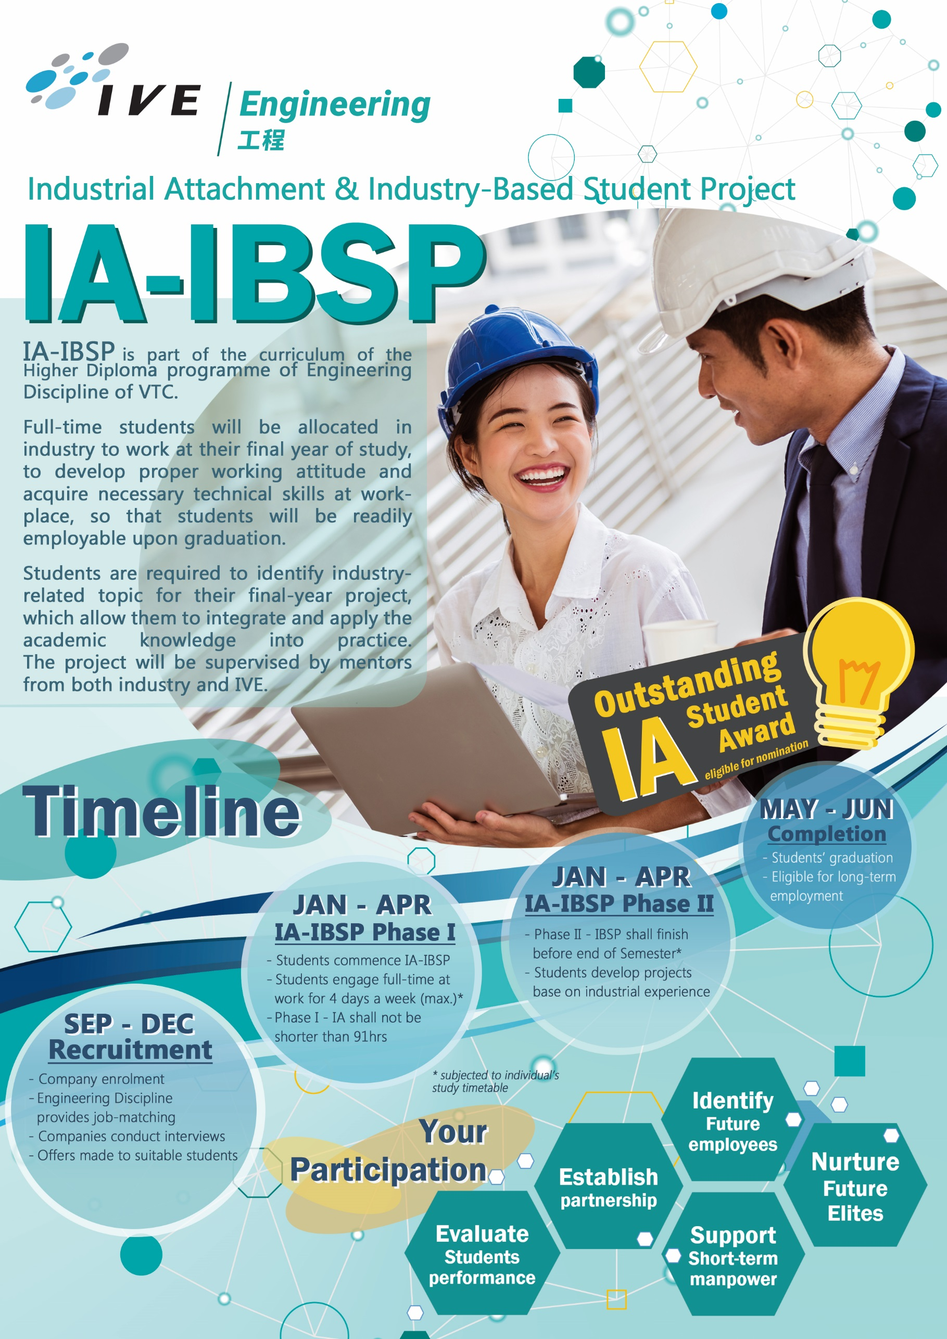
Application Form for IA-IBSP (Spring 2020)
Please complete the form below and send to us:
By Email: eng-ia@vtc.edu.hk By Fax: 2434 5695
By Post: Engineering Discipline Planning Office - Industrial Attachment Team
B318, IVE (Tsing Yi), 20 Tsing Yi Road, Tsing Yi, NT
Organization Particulars
Name of Organization: |  |  |  |  |  |  | Contact Person:
 |  |  |  |  |  |  | Position:
Address: |  |  |  |  |  |  | Tel No.:
 |  |  |  |  |  |  | E-mail:
 |  |  |  |  |  |  | Company Website:
Recruitment
Number of vacancies available for Higher Diploma Programme(s) students below:
 | HD in Civil Engineering |  |  |  |  |  |  |  |  |  | HD in Electrical Engineering
 | HD in Building Studies |  |  |  |  |  |  |  |  |  | HD in Computer Engineering
 | HD in Surveying |  |  |  |  |  |  |  |  |  | HD in Electronic and Communications Engineering
 | HD in Architectural Studies |  |  |  |  |  |  |  |  |  | HD in Mechanical Engineering
 | HD in Environmental Engineering |  |  |  |  |  |  |  |  |  | HD in Building Services Engineering
 | HD in Architectural Technology and Design |  |  |  |  |  |  |  |  |  | HD in Automotive Engineering
 | HD in Testing and Certification |  |  |  |  |  |  |  |  |  | HD in Ophthalmic Dispensing
*Please refer to http://engineering.vtc.edu.hk/en/IndustryPartner.php for programme curriculum
Please “” your expected IA-IBSP Duration
1 month |  |  |  |  | 2 months |  |  |  |  | 3 months |  |  | Other:
Job Nature
Skills Required (if any)
Others (if any) e.g. working hours, allowance, work location etc.
Do you want to receive further information |  |  |  |  |  |  |  | Name and Title: |  |  |  |  |  | Signature:
from IVE Engineering in the future? |  |  |  | Yes / No
Enquiry
Tel: 2436 8694/ 2436 8695/ 3757 9135
E-mail: eng-ia@vtc.edu.hk
Website: http://engineering.vtc.edu.hk

IA-IBSP Information for Participating Organizations
- Statement of Understanding
In order to foster a collaborative understanding among the industrial partner, student and IVE, a tripartite agreement in the form of Statement of Understanding will be signed among the three participating parties.
- Statutory Minimum Wage
Statutory minimum wage does not apply to students taking IA-IBSP, which is a mandatory component of the Higher Diploma programme. IVE shall prepare a “Confirmation of ‘student- internship’ status under the Minimum Wage Ordinance (Cap 608)” for each student undertaking IA-IBSP.
- Insurance Coverage
VTC has in place a Group Personal Accident insurance (GPA) policy covering students; and a Personal Liability insurance policy covering legal liabilities for property damages to third party while students are participating in IA-IBSP (The period ranges from 3 weeks up to 3.5 months).
For further information on the insurance provided by VTC, please contact IVE Engineering.
- Roles of Participating Organizations
We recommend the participating organizations to:
- provide students with a safe and supportive working environment
- offer students with a project or tasks such as research, production, administration; and day-to-day operation with learning opportunities
- assign an industry mentor to supervise the students during their job attachment period and evaluate their performance
- keep in contact with IVE supervisor whenever necessary to facilitate the assessment of the students’ performance
- provide feedback to us on the arrangement
- Evaluation of students performance
We welcome companies to provide guidance for the students engaging in IA-IBSP. To improve the IA-IBSP Scheme in the future, evaluation form will be supplemented approaching the end of the scheme to review students’ performance and provide suggestions to the scheme. Further details will be provided by the respective IVE Supervisors.

